A STUDY ON LANE UTILIZATION

*A project submitted in partial fulfilment of the requirements for the award of degree of*

**BACHELOR OF TECHNOLOGY**

***in***

**CIVIL ENGINEERING**

***Submitted by***

**M. Kanaka Mahalakshmi B. Yoshita**

**(18331A0159) (18331A0106)**

**S. Pavan Kumar K. N. V. Satyam**

**(18331A0114) (18331A0151)**

Under the Guidance of

**Mr. G. Rahul Reddy**

Assistant Professor



DEPARTMENT OF CIVIL ENGINEERING

MVGR COLLEGE OF ENGINEERING (AUTONOMOUS)

VIZIANAGARAM-535005

(Approved by AICTE, New Delhi, and *Permanently* *Affiliated to JNT University, Kakinada, A.P)*

**June 2022**

**DEPARTMENT OF CIVIL ENGINEERING**

**MVGR COLLEGE OF ENGINEERING (AUTONOMOUS)**

**Vision of Department:**

To become a pre-eminent Department of Civil Engineering that brings out technically competent, ethically sound, and globally employable professionals capable of addressing societal challenges by providing sustainable solutions

**Mission of Department:**

Aspire to reach higher quality benchmarks in training students on all skills expected of a computer professional through a meticulously planned yet flexible learning process administered:

1. Design and develop curriculum for UG and PG programs of Civil Engineering that adds value to student competencies abreast with changing industry needs
2. Impart students with knowledge of Civil Engineering and use of modern tools and provide the best learning resources
3. Provide an enabling environment to equip students to serve the society as leading professionals, academicians, innovators and entrepreneurs
4. Promote and undertake academic research to address societal challenges.

**M5**. Provide testing and design consulting services to the industry and create Industry-Academia synergy for improving employability of students

**Program Educational Objectives (PEOs):**

**PEO 1: DOMAIN KNOWLEDGE** Graduates will have the fundamental knowledge of mathematics, science, economics and computing and in-depth knowledge in Civil Engineering concepts through theoretical, laboratory and project-based experiences so as to design, develop and solve engineering problems.

**PEO 2: EMPLOYMENT** Graduates will get employed in national and international; government and private organizations, and will succeed in their chosen engineering careers through their skills, knowledge, personality and aptitude for innovation.

**PEO 3: HIGHER STUDIES & LIFELONG EDUCATION** Graduates will pursue advanced degrees in engineering and other fields; and will have skills of continued, independent and life-long learning to become experts in their profession by self-instilled passion and systematic approach.

**PEO 4: PROFESSIONAL CITIZENSHIP** Graduates will organize and present information, write and speak well, work effectively with strong organizational skills in multidisciplinary teams on team-based engineering projects and practice ethics and have a sense of social responsibility.

**PEO 5: MODERN TOOLS:** Graduates will plan, design, execute, maintain and rehabilitate civil engineering structures / systems and solve civil engineering problems using analytical methods or modern tools and techniques

**Mapping of Mission statements with PEO’s:**

**(3-Highly Relevant, 2-Medium, 1-Low)**

|  |  |  |  |  |  |
| --- | --- | --- | --- | --- | --- |
| MISSION STATEMENTSOF THE DEPARTMENT | *PEO 1* | *PEO 2* | *PEO 3* | *PEO 4* | *PEO 5* |
| **M1** | 3 | 3 | 3 | 2 | 1 |
| **M2** | 3 | - | 2 | 1 | 3 |
| **M3** | 2 | 3 | - | 3 | - |
| **M4** | 1 | 2 | 3 | 2 | 1 |
| **M5** | 1 | 3 | 2 | 3 | 2 |

**POs and PSOs**

**POs**

1. **Engineering Knowledge:** Apply the knowledge of mathematics, science, engineering fundamentals, and an engineering specialization to the solution of complex engineering problems.

2. **Problem Analysis:** Identify, formulate, research literature, and analyze complex engineering problems reaching substantiated conclusions using first principles of mathematics, natural sciences, and engineering sciences.

3. **Design/development of Solutions:** Design solutions for complex engineering problems and design system components or processes that meet t h e specified needs with appropriate consideration for the public health and safety, and the cultural, societal, and environmental considerations.

4. **Conduct Investigations of Complex Problems:** Use research-based knowledge and research methods including design of experiments, analysis and interpretation of data, and synthesis of the information to provide valid conclusions.

5. **Modern Tool usage:** Create, select, and apply appropriate techniques, resources, and modern engineering and IT tools including prediction and modelling to complex engineering activities with an understanding of the limitations.

6. **The Engineer and Society:** Apply reasoning informed by the contextual knowledge to assess societal, health, safety, legal and cultural issues and the consequent responsibilities relevant to the professional engineering practice.

7. **Environment and Sustainability:** Understand the impact of the professional engineering solutions in societal and environmental contexts, and demonstrate the knowledge of, and need for sustainable development.

8. **Ethics:** Apply ethical principles and commit to professional ethics and responsibilities and norms of the engineering practice.

9. **Individual and Teamwork:** Function effectively as an individual, and as a member or leader in diverse teams, and in multidisciplinary settings.

10. **Communication:** Communicate effectively on complex engineering activities with the engineering community and with society at large, such as, being able to comprehend and write effective reports and design documentation, make effective presentations, and give and receive clear instructions.

11. **Project Management and Finance:** Demonstrate knowledge and understanding of the engineering and management principles and apply these to one’s own work, as a member and leader in a team, to manage projects and in multidisciplinary environments.

12. **Life-long Learning:** Recognize the need for and have the preparation and ability to engage in independent and life-long learning in the broadest context of technological change.

**PSOs**

1 - Able to synergize domain knowledge, problem solving skills and emerging tools to develop sustainable solutions in their chosen civil engineering verticals.

2 - Able to communicate and apply civil engineering knowledge for addressing societal challenges.

**Project Outcomes:**

Students will be able to

1. Identify & Formulate the problem statement for the project based on literature survey.
2. Describe a methodology to be adopted for solving the problem.
3. Apply modern tools and techniques for developing solutions to identified problems.
4. Plan, analyze, design and develop solution for Civil Engineering Problems.
5. Develop communication and report writing skills effectively.
6. Practice to work in teams effectively.
7. Appreciate the need for following ethical principles and practices in carrying out the project.

**Mapping of Project Outcomes with PO’s and PSO’s:**

**(3-Highly Relevant, 2-Medium, 1-Low)**

|  |  |  |  |  |  |  |  |  |  |  |  |  |  |  |  |
| --- | --- | --- | --- | --- | --- | --- | --- | --- | --- | --- | --- | --- | --- | --- | --- |
| **PO Attainment for project work** | | | | | | | | | | | | | | | |
| **Project Outcomes** | **CO** | **PO-1** | **PO-2** | **PO-3** | **PO-4** | **PO-5** | **PO-6** | **PO-7** | **PO-8** | **PO-9** | **PO-10** | **PO-11** | **PO-12** | **PSO-1** | **PSO-2** |
| **CO-1** |  |  |  |  | **3** |  | **3** |  |  |  |  |  | **3** | **3** |
| **CO-2** | **3** |  |  | **3** | **3** | **3** | **3** | **3** |  | **3** |  | **3** | **3** | **3** |
| **CO-3** |  |  |  |  | **3** |  | **3** |  |  |  |  |  | **3** | **3** |
| **CO-4** |  | **3** | **3** | **3** | **3** | **3** | **3** | **3** | **3** | **3** |  | **3** | **3** | **3** |
| **CO-5** | **3** | **3** |  |  |  |  | **3** |  |  |  |  |  | **3** | **3** |
| **CO-6** |  |  |  |  |  |  | **3** |  |  |  |  |  | **3** | **3** |
| **CO-7** |  |  |  |  |  | **3** |  | **3** |  | **3** |  |  | **3** | **3** |

**DECLARATION**

We hereby declare that the project titled “A STUDY ON LANE UTILIZATION” is the work done under the guidance of Mr. G. Rahul Reddy, Assistant Professor, Department of Civil Engineering, MVGR College of Engineering during 2021-2022 in partial fulfilment of the requirements for the award of design of project of Bachelor of technology ‘In Civil Engineering’. We ensure that the project is not submitted earlier to any other institution or university.

**CERTIFICATE**

This is to Certify that the project entitled **“A study on lane utilization”** is the bonafide work carried during academic year 2021-2022 by **“M. Kanaka Mahalakshmi, B. Yoshita, S. Pavan Kumar and K. N. V. Satyam”** under the guidance of **Mr. G. Rahul Reddy** Assistant Professor is submitted to the Department of Civil Engineering, MVGR College of Engineering (Autonomous), Vizianagaram in partial fulfilment of the requirements for the award of degree of **‘Bachelor of Technology’** in **‘Civil Engineering’**.

HoD - Civil Engineering Project Guide

Dr. P. Markendeya Raju Mr. G. Rahul Reddy

Head of the Department Assistant Professor

**ACKNOWLEDGEMENT**

We are thankful to the **Dept. of Civil Engineering, MVGR College of Engineering,** for giving me the opportunity to execute this project, which is an integral part of the curriculum in B. Tech program.

We are thankful to my project guide **Mr. G. Rahul Reddy, Assistant Professor** whose encouragement, guidance and support from the initial to the final level enabled me to develop an understanding of the subject. In spite of his busy work schedule, his constant encouragement and co-operative attitude gave me confidence to complete the study within the time frame.

We are thankful to **Dr. P. Markandeya Raju, Professor** and Head of Civil Engineering Department, for all the facilities provided to successfully complete this work.

We are also very thankful to all the faculty members of the department, especially Transportation Engineering specialization faculty for their constant encouragement, in valuable advice, inspiration and blessing during the project.

**ABSTRACT**

The traffic composition on multilane highways in India varies depending upon the vehicle type, engine, manoeuvring ability, etc. This mix of vehicles with different operating capabilities results in a broad range of speed. The inconsistency of traffic flow behaviour with broad range of speed on uninterrupted freeways might largely affect the traffic assignment system. To understand the real traffic behaviour, it requires quantification of some basic characteristics like lane utilization, flow rates, classified volume count, speed of individual vehicle along with the stream speed and its composition.  
  
This research paper has been done to understand the undulations in traffic flow and the efficiency of lane distribution system over the speculated area of study, i.e., two National Highways in the districts of Visakhapatnam and Vizianagaram. The speculated area of study is a multi-lane urban road connecting nearby urban areas (Visakhapatnam and Vizianagaram) with divided carriageway for high-speed travel having partial control of access at frequent locations via basic, weaving, merge and diverge segments (at grade or grade separated). Relatively, limited research has been done on the lane utilization behaviour of different vehicle types on multilane urban roads. The lane utilization is affected by several factors such as vehicle composition, traffic flow rate and vehicular speeds. In the present study, eight hours of video graphic data was collected from a road stretch on Delhi-Gurgaon Expressway, incorporating both peak and off-peak hours. The lane discipline behaviour is studied for five different vehicle categories The results of the present study in the form of lane utilization and lane discipline behaviour by different vehicle types may help in differentiating the characteristics of traffic on expressways in relation to the other roads in India. It may be also helpful to refine the microscopic simulation models and its parameters in order to validate them at micro-level, under traffic conditions prevailing on any relative National Highways.

**TABLE OF CONTENTS**

**ABSTRACT** ix

**LIST OF TABLES** xi

**LIST OF FIGURES** xii

**Page No.**

**Chapter 1: INTRODUCTION 1**

* 1. Objective 3
  2. Scope 3

**Chapter 2: LITERATURE REVIEW 4**

2.1 Overview 4

2.2 Literature Review 4

2.2.1 Lane-Distribution Models and Related Effects on the Capacity for a 6

Three-Lane Freeway Section: Case Study in Italy

2.2.2 Study of Lane Utilization on Delhi-Gurgaon Expressway 7

2.2.3 Study of Speed-Flow Relationships on Individual Freeway Lanes 8

2.2.4 An investigation of lane utilisation on Turkish highways 9

2.3 Conclusion 11

**Chapter 3: DATA AND METHODOLOGY 12**

3.1 Data Collection 12

3.2 Data Extraction 16

3.3 Statistical Analysis 17

3.3.1 Categories of Vehicles Vs Lane Utilized 17

3.3.2 Lane Utilization charted against various vehicle categories 25

3.4 Lane Discipline Analysis 33

**Chapter 4: RESULTS 35**

**Chapter 5: SUMMARY AND CONCLUSIONS 39**

5.1 Two-Wheeler Lane Discipline Analysis 39

**LIST OF TABLES**

|  |  |  |  |
| --- | --- | --- | --- |
| **S.No** | **Table No** | **Title** | **Page No** |
| 1 | 3.1 | Data on lane distribution of different categories of vehicles collected on the area of work - Boyapalem | 12 |
| 2 | 3.2 | Data on lane distribution of different categories of vehicles collected on the area of work – Gambhiram | 14 |
| 3 | 3.3 | Data on lane distribution of different categories of vehicles collected on the area of work – Jonnada | 15 |
| 4 | 3.4 | Data on lane distribution of different categories of vehicles collected on the area of work - Police Barracks | 15 |
| 5 | 4.1 | LUF at NH16 BOYAPALEM | 35 |
| 6 | 4.2 | LUF at Gambhiram | 36 |
| 7 | 4.3 | LUF at Jonnada | 37 |
| 8 | 4.4 | LUF at Police Barracks | 38 |

**LIST OF FIGURES**

|  |  |  |  |
| --- | --- | --- | --- |
| **S.No** | **Figure No** | **Title** | **Page No** |
| 1 | 1.1 | Route Map of NH 16 connecting Kolkata – Chennai (originally part of Golden Quadrilateral project) | 2 |
| 2 | 3.1 | NH16 BOYAPALEM AREA 4 LANE ROAD | 13 |
| 3 | 3.2 | ANANDAPURAM-PENDURTHI HIGHWAY (NH5/New NH16) | 14 |
| 4 | 3.3 | NH16 Boyapalem - 2 Wheeler Vehicles Vs Lane Segment Utilized | 17 |
| 5 | 3.4 | NH16 Boyapalem - 3 Wheeler Vehicles Vs Lane Segment Utilized | 17 |
| 6 | 3.5 | NH16 Boyapalem - 4 Wheeler Vehicles Vs Lane Segment Utilized | 18 |
| 7 | 3.6 | NH16 Boyapalem - Heavy Good Vehicles Vs Lane Segment Utilized | 18 |
| 8 | 3.7 | Gambhiram - 2 Wheeler Vehicles Vs Lane Segment Utilized | 19 |
| 9 | 3.8 | Gambhiram - 3 Wheeler Vehicles Vs Lane Segment Utilized | 19 |
| 10 | 3.9 | Gambhiram - 4 Wheeler Vehicles Vs Lane Segment Utilized | 20 |
| 11 | 3.10 | Gambhiram – Heavy Good Vehicles Vs Lane Segment Utilized | 20 |
| 12 | 3.11 | Jonnada - 2 Wheeler Vehicles Vs Lane Segment Utilized | 21 |
| 13 | 3.12 | Jonnada - 3 Wheeler Vehicles Vs Lane Segment Utilized | 21 |
| 14 | 3.13 | Jonnada - 4 Wheeler Vehicles Vs Lane Segment Utilized | 22 |
| 15 | 3.14 | Jonnada – Heavy Good Vehicles Vs Lane Segment Utilized | 22 |
| 16 | 3.15 | Police Barracks – 2 Wheeler Vehicles Vs Lane Segment Utilized | 23 |
| 17 | 3.16 | Police Barracks – 3 Wheeler Vehicles Vs Lane Segment Utilized | 23 |
| 18 | 3.17 | Police Barracks – 4 Wheeler Vehicles Vs Lane Segment Utilized | 24 |
| 19 | 3.18 | Police Barracks – Heavy Good Vehicles Vs Lane Segment Utilized | 24 |
| 20 | 3.19 | NH16 Boyapalem – Lane 1 Utilization | 25 |
| 21 | 3.20 | NH16 Boyapalem – Lane 2 Utilization | 25 |
| 22 | 3.21 | NH16 Boyapalem – Lane 3 Utilization | 26 |
| 23 | 3.22 | NH16 Boyapalem – Lane 4 Utilization | 26 |
| 24 | 3.23 | Gambhiram – Lane 1 Utilization | 27 |
| 25 | 3.24 | Gambhiram – Lane 2 Utilization | 27 |
| 26 | 3.25 | Gambhiram – Lane 3 Utilization | 27 |
| 27 | 3.26 | Gambhiram – Lane 4 Utilization | 28 |
| 28 | 3.27 | Gambhiram – Lane 5 Utilization | 28 |
| 29 | 3.28 | Gambhiram – Lane 6 Utilization | 28 |
| 30 | 3.29 | Jonnada – Lane 1 Utilization | 29 |
| 31 | 3.30 | Jonnada – Lane 2 Utilization | 29 |
| 32 | 3.31 | Jonnada – Lane 3 Utilization | 30 |
| 33 | 3.32 | Jonnada – Lane 4 Utilization | 30 |
| 34 | 3.33 | Police Barracks – Lane 1 Utilization | 31 |
| 35 | 3.34 | Police Barracks – Lane 2 Utilization | 31 |
| 36 | 3.35 | Police Barracks – Lane 3 Utilization | 32 |
| 37 | 3.36 | Police Barracks – Lane 4 Utilization | 32 |
| 38 | 4.1 | NH16 BOYAPALEM - Vehicle Category wise Lane Discipline Analysis | 35 |
| 39 | 4.2 | Gambhiram - Vehicle Category wise Lane Discipline Analysis | 36 |
| 40 | 4.3 | Jonnada - Vehicle Category wise Lane Discipline Analysis | 37 |
| 41 | 4.4 | Police Barracks - Vehicle Category wise Lane Discipline Analysis | 38 |

**CHAPTER -1**

**INTRODUCTION**

The purpose of this project is to study the traffic characteristics on lane utilization. Lane Utilization can roughly be defined as how the rate of traffic flow is distributed among the available number of lanes in a given section. The importance of studying lane utilization comes from the fact that it is one of the important parameters for calibrating the parameters of micro-simulation traffic models. Traffic microsimulation models simulate the behaviour of individual vehicles within a predefined road network and are used to predict the likely impact of changes in traffic patterns resulting from changes to traffic flow or from changes to the physical environment. Driving disorder, such as having difficulty in staying in the lane, abrupt lane changes and driving on the shoulder are typical consequences of many dangerous driving circumstances and can be grouped under the heading of “lateral discipline of driving”. Recognition of these situations is largely observational and spotted/examined by police at high costs. In this project, a discrete analysis on lane utilization factor is made by observing the traffic in a time period of two hours each on peak hour and off-peak hour. The factors such as vehicle composition in each lane, type of vehicle travelling in each lane and sub-lanes are considered. A simple tallying is done for obtaining the volume of the traffic in individual lanes. The data is then extracted to excel sheets, bar diagrams and pie charts are fabricated for the better understanding of the study on lane utilization.

On most freeways, a number of factors interact to produce lane-to-lane variations in speed and volume which are both site and volume dependent. In addition to their independent variations, speed and flow are also shown to interact differently across different lanes and result in different underlying speed-flow relationships.

Many states have implemented large-scale transportation management systems to improve mobility in urban areas. These systems are highly prone to missing and erroneous data, which results in drastically reduced data sets for analysis and real-time operations. Imputation is the practice of filling in missing data with estimated values. Currently, the transportation industry generally does not use imputation as a means for handling missing data. Other disciplines have recognized the importance of addressing missing data and, as a result, methods and software for imputing missing data are becoming widely available. The feasibility and applicability of imputing missing traffic data are addressed, and a preliminary analysis of several heuristic and statistical imputation techniques is performed. Preliminary results produced excellent performance in the case study and indicate that the statistical techniques are more accurate while maintaining the natural characteristics of the data.

Figure 1: Route Map of NH 16 connecting Kolkata – Chennai (originally part of Golden Quadrilateral project)

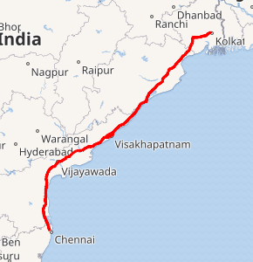

**1.1 Objective**

* To study lane discipline and lane utilization behavior for different categories of vehicles on various national highways.
* To compare the results of lane utilization factors for different lanes and vehicles observed on the road.
* To model lane utilization using parameters like classified traffic volume and average stream speed for prevailing roadway and traffic conditions on the selected area of study.

**1.2 Scope**

For this purpose, two locations each in the districts of Vizianagaram and Visakhapatnam along the highways NH-16, NH-26 have been considered.

The locations taken for the study are Boyapalem (NH-16,VSP), Ghambiram (NH-16,VSP), Jonnada (NH-26,VZM), Police Barracks area (NH-26,VZM).

The different vehicle categories considered for the study are car, two-wheeler, three-wheeler, heavy good vehicle (i.e. bus and trucks).

**CHAPTER -2**

**LITERATURE REVIEW**

**2.1 Overview**

A large amount of research has been completed in the field of lane distribution, prior. The current literature review summarizes the current state of knowledge and verifies various methods that have been used. It also mentions the need to investigate for the current study case.

**2.2 Literature Review**

Distraction in driving is responsible about three in four crashes and can be considered to be misallocated attention. NHTSA’s 100-car naturalistic driving study provides compelling evidence of its importance, Smiley [2005]. Dangerous driving is caused by a number of reasons such as aggressive, impaired or distracted driving resulting in many vehicular accidents. A possible concise classification of its breakdown, largely from the traffic engineering perspective, can be shown in Figure 1. The diagram accounts for the general categories of dangerous driving in a simple structure. Distracted and fatigue driving can also be considered impaired. Inattentive driving will impair driving performance differently than aggressive driving because the actions are deliberate with aggressive driving. The impact of the various types of impairment will differ, for example, there is some evidence that standard deviation of lane position increases with visual distraction and decreases with cognitive distraction, e.g. DfT [2004] and Nowakowski [2002].

Aggressive driving, from psychologists’ point of view, can also be categorised as (a) intentional acts of aggression toward others, (b) negative emotions experienced while driving, and (c) risk-taking [Dula and Geller, 2003]. Driver distractions, like using mobile phones, adjusting radio (caste/CD players), moving an object in-vehicle, smoking related activities, outside person (object/event) have been studied by others and many accidents have been associated with these causes. For example, Stutts and Hunter [2003] reported that about 13% of crashes occurred in their study sample were resulted by driver distraction. Eby and Vivoda [2003] found that 2.7% of drivers in Michigan were using a mobile phone at any given moment during daylight hours and this rate was consistent with the US national rate reported by NHTSA [2001]. According to Brookhuis et al [1991] and Fairclough et al [1991] typical consequences of phone use while driving are poorer lane keeping, more variable speed and a slower reaction time to hazards. Lamble et al [1999] found that engaging in a demanding phone conversation while driving shortened brake reaction times significantly. Most importantly severe accidents also happen due to alcohol-impaired driving (drink-driving), see Ross [1993] for a detailed review. The causes of dangerous driving (mentioned above) are subject to different legal regulations. Whereas smoking or adjusting the radio during driving, for example, are considered as minor distractions, drinkdriving is totally unacceptable and offenders are penalised if caught almost everywhere in the world. However, all of these cases have commonalities in terms of irregular and dangerous driving patterns they exhibit, in particular lateral driving disorder (i.e. poor lane keeping). Irregular behaviour in the longitudinal direction, however, may not necessarily relate to these offences, as they are mainly in the form of speeding and harsh breaking, which may be caused by many other factors and detected by other means. Most jurisdictions have highway code offences for dangerous driving such as driving without due care attention and driving without consideration. According to current legislations [DfT, 2006], a driver is guilty of dangerous driving if the way he or she drives falls far below what would be expected of a competent and careful driver; and it would be obvious to a competent and careful driver that driving in that way would be dangerous. Whereas dangerous is explicitly defined within the 1991 Act, careless is not. There are two forms of the Careless and Inconsiderate Driving offence: driving without due care and attention, and driving without reasonable consideration for other road users.

Paved shoulder on the left extreme is meant for two-wheelers and pedestrians

The increasing number of accidents on four-lane highways, mainly due to human negligence, is a cause for concern for Transport department authorities. According to statistics available with Regional Transport Offices, four-lane highways account for over 30 per cent of deaths in road accidents. In 2014, of the total 15,191 deaths in road accidents, 5,043 were on four-lane highways. Transport officials attribute several reasons for these accidents. Primary among them are driving without sufficient gap between vehicles, abrupt lane cutting, speeding at places where there are pedestrian as well as vehicle crossings, parking on the highway instead of parking bay and sleeping on the wheel. During the Road Safety Week, officials insisted that drivers should follow lane discipline on the highway. The paved shoulder on the left extreme is meant for two-wheelers and pedestrians; the left lane is for heavy vehicles and light vehicles should use the right lane. They should always use indicators while overtaking vehicles through the other lane and avoid abrupt lane cutting. Vehicles should not be driven closer to the median and should maintain a gap of four feet. This would prevent accidents caused by sudden attempts by animals or pedestrians to cross the road from the median. Accidents are also caused by vehicles using the wrong lane in the opposite direction.

# **2.2.1 Lane-Distribution Models and Related Effects on the Capacity for a Three-Lane Freeway Section: Case Study in Italy**

One of the first studies on the lane distribution for multi-lane carriageways was that by the US Public Roads Administration (Normann, 1942). Several highway authorities carried out significant studies on lane distribution in the late 1960s and 70s on rural and urban highways and freeways with two-, three-, four- and five-lane unidirectional carriageways (Taragin, 1958) (Lynch et al., 1969). In these studies, the non-homogeneous use of a multi-lane road was highlighted, along with the observation that the percentage of use of the shoulder lane (by which the authors mean the lane nearest to the hard shoulder, which is the right-hand lane for countries driving on the right-hand side of the road) was inversely proportional to the total flow. With increasing flow, vehicles seemed to prefer the middle or median lanes (by median lane the authors mean the lane closest to the central reservation and the left-hand lane for countries driving on the right-hand side of the road). The first multiple regression models were proposed in these studies to fit the functional formulation of lane use percentage, known as Lane Flow Ratio (LFR).

A few years later, Pignataro (1973) carried out several studies on the American three-lane freeway system, which reflected the typical variation in traffic flows by lane. Under conditions of low flow, he observed that almost half the total flow travelled by preference on the middle lane. With increasing flow, he observed that flow on the two inner (fastest) lanes (middle and median lanes) was equally distributed with reduced usage of the shoulder (slowest) lane.

A detailed study of the variability in traffic flow characteristics and parameters across lanes was conducted by Allen et al. (1985) in Ontario, Canada, in which they demonstrated some differences in speed, flow and density distribution. In the study, and in subsequent research, Hall and Gunter (1986) also showed that the lane capacity values are different, these being lower for the shoulder lane and higher for the middle and median lanes.

Nordaen and Rundmo (2009) and Ozkan et al. (2006) suggested that drivers’ behaviour is significantly affected by cultural differences among countries. This might explain the differences in the pattern of lane changes for different countries as reported by Ferrari (1989). Gunay (2004) in his study on Turkish highways also reported that the lane utilization coefficients are significantly different from those obtained in developed countries. Gunay explained the reasons behind that behavior by the so called “untidy lanes” where no marking lines between lanes were present with poor lane discipline. Some studies (Knoop et al. 2010 and Lee and Park 2012) considered the lane utilization as a function of traffic density. From the literature review it may be noted that most of the research works on lane usage and distribution are conducted in developed countries. Also, it may be noted that there have been very few studies conducted for studying lane distribution on multilane roads.

**2.2.2 Study of Lane Utilization on Delhi-Gurgaon Expressway**

Sagar Kurlea , Krishna N. S. Behara a, Rajendra Prasad J.a , Shriniwas Arkatkarb,*, Ashoke Kumar Sarkara

In a “Study of Lane Utilization on Delhi-Gurgoan expressway” conducted by Sagar Kurle, Krishna Nikhil Sumanth Behara, J. Rajendra Prasad, Shriniwas Shrikant Arkatkar, they highlight that the lane utilization is affected by several factors such as vehicle composition, traffic flow rate and vehicular speeds. They based their findings on eight hours of video graphic data collected from a road stretch on Delhi-Gurgaon Expressway, incorporating both peak and off-peak hours. The main objective of the study is to study the lane usage characteristics on Delhi-Gurgaon expressway which is a urban multi-lane road. Lane use distributions represent the proportion of an individual lane’s traffic out of the total traffic at a given multilane roadway. Pignataro (1973) examined a number of studies of American three-lane freeways. From these studies, a typical variation in traffic flows was observed to exist. Specifically, for freeways with three lanes in one direction, and under conditions of low flow, the center lane was observed to carry the bulk of the total flow, or approximately 47 percent. The shoulder lane also carried a significant portion of the total traffic, namely 31 percent, while the median side lane was observed to carry the lowest percentage, approximately 22 percent. As the total volume increased, Pignataro observed that the flows in both the shoulder and center lanes dropped, while the percentages of total flow in the median lane increased. When the arrival rate was sufficiently high, around 1670 veh/h/lane, the percentage of flow in both the median and center lanes were observed to be equal, each carrying approximately 37 percent of the total flow. At these higher flows, the shoulder lane was underutilized, carrying only 26 percent of the total traffic flow. May (1990) supported these observations for U.S. three-lane freeways and expanded the focus to include the observed traffic flow variations for a German autobahn. For the German freeway, the distribution was similar to that of the American structures in that the percentages of total flow in the shoulder and center lanes continually decreased, while the median lane flow increased. However, the German data differed from the American studies in that the flows on the median and center lanes were not equal under high flows. Specifically, under high flows, the median lane was observed to carry significantly higher flows than both the shoulder and center lanes. Some of the researchers applied the lane utilization concept to maintain desired speed and to minimize the frequency of lane changing on freeways (Moriarty and Langley 1998; Wang and Liu 2005). Various studies have used traffic volume as a practical measure to explain lane use distributions especially for uncongested traffic condition (Amin and Banks 2005; Hurdle, Merlo, and Robertson 1997; Yang, Xhang, and Gao 2008; Hong and Oguchi 2008; Smith and Conklin 2002) However, previous studies used field measured volume for uncongested condition and often used simulated volume and density for congested condition in determining lane use distribution. Carter, Rakha, and Van Aerde (1999) used occupancy for the study of lane use distribution. Papageorgiou et at. (1989) have studied several situations pertaining to knowledge of the traffic volume distribution to lanes and its assistance in traffic management of suburban highways. Many studies (for example, Yousif and Hunt (1995) and Brackstone et al. (1998)) have asserted that for motorway segments far away from merge or diverge sections; vehicles are distributed mainly based on total traffic flow. The lane use distribution is closely related to the lane utilization, capacity, and safety. In addition, the lane use distribution is an informative factor for understanding lane-by-lane variations on freeways for microscopic traffic simulation models (Banks 2006).

# **2.2.3 Study of Speed-Flow Relationships on Individual Freeway Lanes**

[V. F. Hurdle](https://journals.sagepub.com/doi/abs/10.3141/1591-02), [Mark I. Merlo](https://journals.sagepub.com/doi/abs/10.3141/1591-02), [Doug Robertson](https://journals.sagepub.com/doi/abs/10.3141/1591-02)

Many researchers have examined the form of the relationship between speed and flow on freeways. However, these researchers have concentrated on relationships for the freeway as a whole instead of on individual lanes. In this study, the relationship was examined for each of the three lanes at two locations on Highway 401 in metropolitan Toronto. It proved possible to accurately describe the mean speed in each lane with simple linear functions over the range of flows of most practical interest. Cubic functions provided comparable results over a wider range of flows, but it appears unlikely that the very high and very low flows are of sufficient interest to justify the added complexity. When an attempt was made to examine the relationship between speed and flow for the entire roadway, the linear functions were not adequate, but cubic functions performed reasonably well. However, the details of the full roadway curves are quite different from those of the curves described in the 1994 *Highway Capacity Manual.* In particular, the curves described in the manual are much steeper than the Highway 401 curves at high flows, implying a much more rapid loss of performance as flow approaches capacity than was observed. The full roadway curves are also surprisingly different from the curves for the individual lanes.

**2.2.4 An investigation of lane utilisation on Turkish highways**

‘Lane utilisation’, also known as lane split, can be defined by the percentage distribution of the total traffic flow to the individual lanes of multilane carriageways.1 ‘Lane-based-driving discipline’ is the tendency to drive within a lane by keeping to the centre as closely as possible unless lane changing,2 and should not be confused with a similar term ‘lane discipline’, meaning the tendency to choose the most appropriate lane with respect to the current speed of the vehicle, or in short, keeping to the slower lane unless overtaking.3 Some researchers may prefer to use ‘lateral position discipline’ for the second definition and ‘lane choice’ for the third one. All of these three definitions can be grouped under the heading of ‘lateral discipline’. To bring the concept to life, two photographs are shown in Fig. 1, as an example of two different levels of lane-based-driving discipline. Regarding the lane terminology, throughout the paper it should be noted that ‘shoulder lane’, ‘middle lane’ and ‘median lane’, will refer to nearside, middle and offside lanes, respectively.

As summarised in the following, investigation of lane utilisation has been an important issue for some researchers. Mahalel and Hakkret4 revealed that, in a multi-lane unidirectional highway, the arrival pattern of vehicles in one lane is dependent on the arrival patterns of vehicles in the other lanes, and this feature necessitates the use of models that simultaneously describe vehicle arrivals on the roadway. Since the arrival pattern of vehicles in a cross-section of a multi-lane roadway is not random, the assumption of independent vehicle arrivals may lead to inaccuracies in traffic flow analyses. Concerning highway safety, Mahalel and Hakkret stated that relatively high usage of the median lane as well as a transfer of vehicles from the shoulder lane to the median lane, as traffic flow increases, may have a significant negative impact. Chang and Kao5 carried out a macroscopic investigation of lane-changing characteristics in the USA, indicating the need for more understanding of the phenomena for better use of limited resources. Heidemann6 argued that if a more balanced lane utilisation were to be achieved, for large traffic flows, the increase in capacity and the decrease in traffic congestion would be considerable. Later, Golias and Tsamboulas7 scrutinised the problem from the aspects of macrolevel estimation of lane usage on highways. They stated that the heterogeneous distribution of vehicles over the lanes is a critical factor in designing highway intersections, as merging, diverging and transit traffic volumes in each lane need to be known.

**Data Collection and Conclusion**

The traffic flow observations were carried out in Istanbul, the north-west of Turkey, taking place at nine different sites in order to meet the objectives of a broader piece of research. Only the data from five of these sites were appropriate to be included in the paper. While Sites 2 and 3 formed the main data collection places to serve the majority of the research objectives, the rest of the sites provided additional data to investigate whether the findings are similar in various places. The data collection sites were selected in such a way that the most important requirements of the research are met and the number of external effects are kept to a minimum, in order to concentrate on lateral characteristics. These sites were straight and zero gradient sections of multilane uninterrupted highways, away from entrance and exit ramps. They all had suitable vantage points: either a pedestrian or roadway bridge passing over the carriageway being considered.

Observations of lateral position of traffic revealed that distribution of vehicles within a lane is less tidy in Turkey than in developed countries and the degree of untidiness may vary from one highway to another. 11 Various factors influence the shape of this distribution. The width of the shoulder has a significant effect on the utilisation of the lanes. In sites with no conditions, the proportion of traffic in the median lane is significant. As the flow approaches capacity, a considerable amount of lane changes from the median lane to the middle and shoulder lanes takes place. Therefore, this might be one of the reasons behind the instability in traffic during the maximum flow operations. A supportive argument was made earlier by Gedizlioglu and Akad13 stating that in the flowspeed-density observations in Turkey, generally, scarcity of data around the capacity is noted, leading to a jump from the stable flow to the unstable flow regions. First, in the design of intersections, the estimation of lane flows and the proportion of transit and merging/diverging vehicles is important. Application of conventional values, established by western traffic analysts, may not be accurate in Turkey. Second, the investigation of a potential increase in the maximum reachable flows with more balanced lane utilisation gives scope for further research.

**2.3 Conclusion**

The results of the present study in the form of lane utilization and lane discipline behaviour by different vehicle types may help in differentiating the characteristics of traffic on expressways in relation to the other roads in India. It may be also helpful to refine the microscopic simulation models and its parameters by using data collected about Indian roads’ traffic flow in order to validate them at micro-level.

**CHAPTER -3**

**DATA AND METHODOLOGY**

This chapter describes how data were collected and how they were evaluated to identify factors associated with Lane Utilization using data from districts of Vizianagaram and Visakhapatnam along the highways NH-16, NH-26.

**3.1 Data Collection**

The main data collection task was to manually collect the categorical vehicular count i.e., car, two-wheeler, three-wheeler, heavy good vehicle through an instantaneous cross section of the lane in individual lanes at peak hour and off hour. The time periods for data collection were opted out such that it covers wider variation of traffic flow conditions. The lanes are distributed as lane 1, lane 1.5, lane 2, lane 2.5 and so on. The data was then used in graphical, spatial and a statistical analysis for Lane Utilization.

Table 1: Data on lane distribution of different categories of vehicles collected on the area of work – Boyapalem

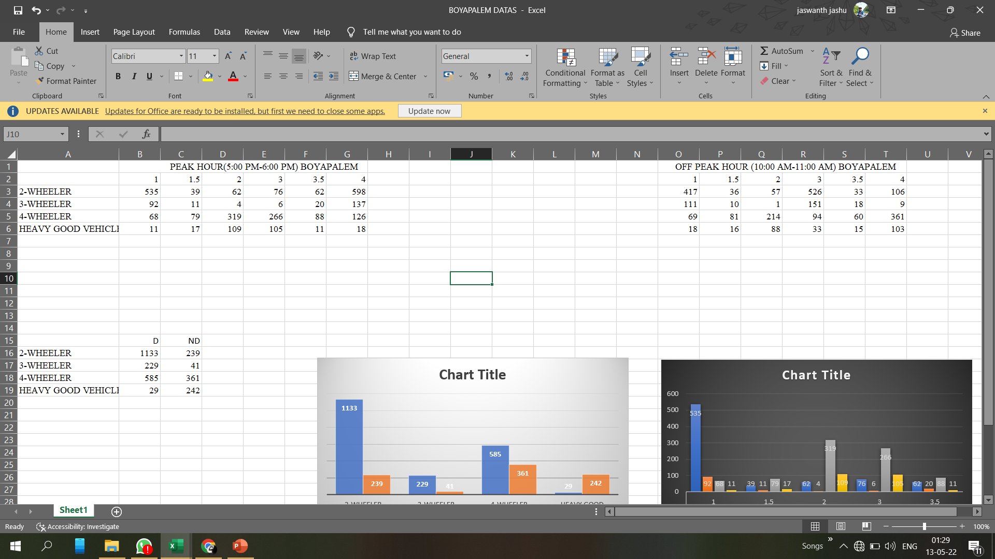

Figure 2: NH16 BOYAPALEM AREA 4 LANE ROAD

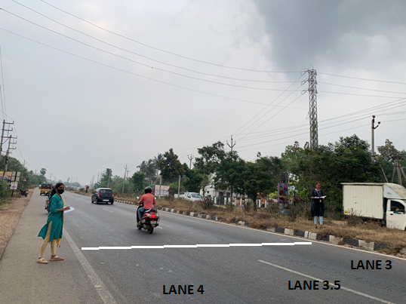

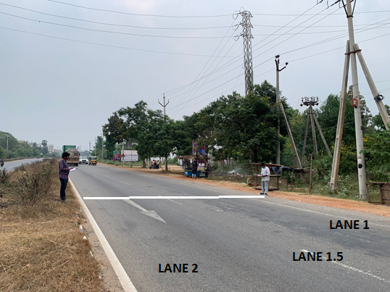

Table 2: Data on lane distribution of different categories of vehicles collected on the area of work – Gambhiram



Figure 3: ANANDAPURAM-PENDURTHI HIGHWAY (NH5/New NH16)

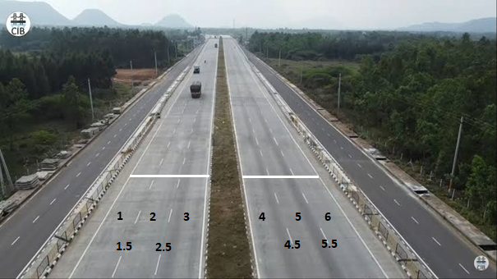

Table 3: Data on lane distribution of different categories of vehicles collected on the area of work – Jonnada

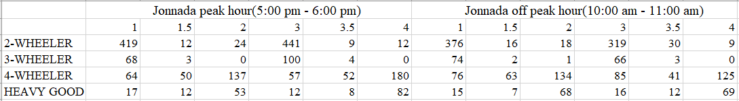

Table 4: Data on lane distribution of different categories of vehicles collected on the area of work - Police barracks

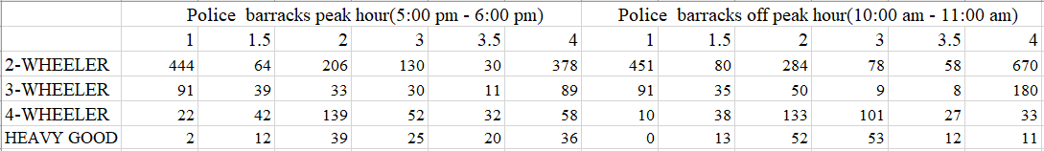

**3.2 Data Extraction**

Two hours of traffic flow data was utilized for calculating the lane utilization factor. The observed time period was further divided into short intervals of 2.5 minutes, 1 minute and 20 seconds based on the varying flow levels for analysing the lane utilization behaviour of different class of vehicles on different lanes. For this purpose, the flow values and lane usage factors were extracted from the data using four reference points (to form rectangular trap) as identified in the field, while capturing the data. Broadly, five vehicle categories were observed on the study stretch, namely, motorized three-wheelers, motorized four-wheelers, motorized two-wheelers and heavy good vehicles. For the purpose of calculating lane utilization, the lanes were classified into three distinct types (1 denoting median-side, 2 denoting next to median side, 3 denoting before shoulder side, 4 denoting shoulder-side, 1.5 and 2.5), each representing vehicle position on the expressway from the median, hence making it possible to quantify the degree of lane-discipline followed under the prevailing basic roadway and traffic conditions. For example, '1.5' represents that vehicle is violating lane discipline and travelling on lane area between lane 1 and lane 2. Same is applicable for lane 2.5 also. But for the purpose of modelling lane-wise lane distribution, the analysis has been done, only for the vehicles travelling on distinct lanes i.e. lanes 1, 2, 3 and 4.

The lane utilization factor estimated for the purpose of this study is given below in equation1:

LUFi=Vi/V ----- (1)

where;

Vi= Traffic volume for ith lane

V= Volume of the Heaviest lane

LUFi = Lane Utilization Factor in percentage for ith lane

**3.3 Statistical Analysis**

**3.3.1 Categories of Vehicles Vs Lane Utilized**

To understand vehicle preference for particular lane the data collected was charted by categories of vehicles against lanes utilized.

Figure 4: NH16 Boyapalem - 2-Wheeler Vehicles Vs Lane Segment Utilized

Figure 5: NH16 Boyapalem – 3-Wheeler Vehicles Vs Lane Segment Utilized

Figure 6: NH16 Boyapalem – 4-Wheeler Vehicles Vs Lane Segment Utilized

Figure 7: NH16 Boyapalem - Heavy Good Vehicles Vs Lane Segment Utilized

Figure 8: Gambhiram – 2-Wheeler Vehicles Vs Lane Segment Utilized

Figure 9: Gambhiram – 3-Wheeler Vehicles Vs Lane Segment Utilized

Figure 10: Gambhiram – 4-Wheeler Vehicles Vs Lane Segment Utilized

Figure 11: Gambhiram – Heavy Good Vehicles Vs Lane Segment Utilized

Figure 12: Jonnada – 2-Wheeler Vehicles Vs Lane Segment Utilized

Figure 13: Jonnada – 3-Wheeler Vehicles Vs Lane Segment Utilized

Figure 14: Jonnada – 4-Wheeler Vehicles Vs Lane Segment Utilized

Figure 15: Jonnada – Heavy Good Vehicles Vs Lane Segment Utilized

Figure 16: Police Barracks – 2-Wheeler Vehicles Vs Lane Segment Utilized

Figure 17: Police Barracks – 3-Wheeler Vehicles Vs Lane Segment Utilized

Figure 18: Police Barracks – 4-Wheeler Vehicles Vs Lane Segment Utilized

Figure 19: Police Barracks – Heavy Good Vehicles Vs Lane Segment Utilized

**3.3.2 Lane Utilization charted against various vehicle categories**

To understand lane utilization at various points of time by different categories of vehicles, the data collected was charted by lane utilization against categories of vehicles.

Figure 20: NH16 Boyapalem – Lane 1 Utilization

Figure 21: NH16 Boyapalem – Lane 2 Utilization

Figure 22: NH16 Boyapalem – Lane 3 Utilization

Figure 23: NH16 Boyapalem – Lane 4 Utilization

Figure 24: Gambhiram – Lane 1 Utilization

Figure 25: Gambhiram – Lane 2 Utilization

Figure 26: Gambhiram – Lane 3 Utilization

Figure 27: Gambhiram – Lane 4 Utilization

Figure 28: Gambhiram – Lane 5 Utilization

Figure 29: Gambhiram – Lane 6 Utilization

Figure 30: Jonnada – Lane 1 Utilization

Figure 31: Jonnada – Lane 2 Utilization

Figure 32: Jonnada – Lane 3 Utilization

Figure 33: Jonnada – Lane 4 Utilization

Figure 34: Police Barracks – Lane 1 Utilization

Figure 35: Police Barracks – Lane 2 Utilization

Figure 36: Police Barracks – Lane 3 Utilization

Figure 37: Police Barracks – Lane 4 Utilization

**3.4 Lane Discipline Analysis**

The main data collection task was to manually collect the categorical vehicular count i.e., car, two-wheeler, three-wheeler, heavy good vehicle through an instantaneous cross section of the lane in individual lanes at peak hour and off hour. The time periods for data collection were opted out such that it covers wider variation of traffic flow conditions. The lanes are distributed as lane 1, lane 1.5, lane 2, lane 2.5 and so on. each representing vehicle position on the expressway from the median, hence making it possible to quantify the degree of lane-discipline followed under the prevailing basic roadway and traffic conditions. For example, '1.5' represents that vehicle is violating lane discipline and travelling on lane area between lane 1 and lane 2. Same is applicable for lane 2.5 and lane 3.5 also. But for the purpose of modelling lane-wise lane distribution, the analysis has been done, only for the vehicles travelling on distinct lanes i.e., lanes 1, 2, 3 and 4. Speed is measured using the trap length for each vehicle. Average speed for each category of vehicle besides the stream speed is calculated for the given time interval. The data was then used in graphical, spatial and a statistical analysis for Lane Utilization.

Speed-oriented Lane discipline should be mandatory for roads that are long without intersections, especially on highways. In this system, all slow-moving vehicles like trucks, autorickshaws and two-wheelers should move on the left lane and allow faster vehicles like cars and jeeps to their right. Change of lane is allowed only while overtaking. Slow-moving vehicles should return to the left lane after overtaking.

However, it is generally noticed on highways that trucks drive slowly on the right lane, forcing other road users to overtake them from the left. Two parallel, slow-moving vehicles end up slowing down traffic.

Enforcement of lane discipline is one of the most difficult and challenging tasks before police, especially on highways. It requires a large number of police personnel to book violators. Many a time, booking of cases on roads and highways results in traffic hold-ups. Therefore, creating awareness and educating road users is equally important. Special lane-discipline tests should be conducted during issuance and renewal of driving licences. Installation of surveillance cameras and automated challaning of violators is another method to enforce lane discipline. Apart from police and transport department officials, NGOs should come forward to educate people to make roads safer and less congested.

To understand vehicle preference for particular lane the data collected was charted by categories of vehicles against lanes utilized by tallying the volume of each vehicle category, i.e., two-wheeler, four-wheeler, three-wheeler, heavy good vehicles of individual lane to the total volume of all vehicles combined in that respective lane. The data is transferred into excel format and pie charts are obtained through insert window.

To understand lane utilization at various points of time by different categories of vehicles, the data collected was charted by lane utilization against categories of vehicles.

**CHAPTER -4**

**RESULTS**

Section 3.3 provides details of numerical analysis done on the collected data to establish the lane discipline of various vehicles. The following are the plotted results of lane discipline calculated for the data.

Figure 38: NH16 BOYAPALEM - Vehicle Category wise Lane Discipline Analysis

Table 5: LUF at NH16 BOYAPALEM

|  |  |  |
| --- | --- | --- |
| **Lane** | **Total Volume** | **LUF** |
| 1 | 706 | 0.8 |
| 2 | 494 | 0.562 |
| 3 | 879 | 1 |
| 4 | 453 | 0.515 |

Figure 39: Gambhiram - Vehicle Category wise Lane Discipline Analysis

Table 6: LUF at Ghambiram

|  |  |  |
| --- | --- | --- |
| **Lane** | **Total Volume** | **LUF** |
| 1 | 52 | 0.75 |
| 2 | 69 | 1 |
| 3 | 69 | 1 |
| 4 | 56 | 0.81 |
| 5 | 67 | 0.97 |
| 6 | 45 | 0.65 |

Figure 40: Jonnada - Vehicle Category wise Lane Discipline Analysis

Table 7: LUF at Jonnada

|  |  |  |
| --- | --- | --- |
| **Lane** | **Total Volume** | **LUF** |
| 1 | 568 | 0.93 |
| 2 | 214 | 0.35 |
| 3 | 610 | 1 |
| 4 | 274 | 0.44 |

Figure 41: Police Barracks - Vehicle Category wise Lane Discipline Analysis

Table 8: LUF at Police barracks

|  |  |  |
| --- | --- | --- |
| **Lane** | **Total Volume** | **LUF** |
| 1 | 559 | 0.99 |
| 2 | 417 | 0.74 |
| 3 | 237 | 0.422 |
| 4 | 561 | 1 |

**CHAPTER – 5**

**SUMMARY AND CONCLUSIONS**

**5.1 Two-Wheeler Lane Discipline Analysis**

Consider figures - 38,39,40,41 mentioning lane discipline of 2 wheeler vehicles on different road cross-sections selected. 75% of vehicles from all data collected follow lane discipline. Majority of the 2 wheelers follow lane discipline considering their smaller size.